Java automation cucumber

Sql for business

Jmeter

Api 14hrs

Api Rahul start from jira authomation from chapter 4 to 16

Soap ui

Sdet/qa

Robotic process Automation.

Learn sql + pen test. (Gold Hack Security start a penetration test business )

Get penetration testing certified

<https://www.google.com/search?sxsrf=ALeKk02jhk4EwpmcrREg7kUqgIZ9E_2wDg%3A1590504163330&source=hp&ei=4yrNXvznEYyclwSOt4WoDw&q=start+a+penetration+testing+business&oq=start+a+penetr&gs_lcp=CgZwc3ktYWIQARgAMgIIADIGCAAQFhAeMgYIABAWEB46BAgjECc6BQgAEJECOgUIABCDAToECAAQQzoHCAAQgwEQQzoHCAAQFBCHAlD8CFj5JmDVM2gAcAB4AIABVogB6geSAQIxNJgBAKABAaoBB2d3cy13aXo&sclient=psy-ab>



With an eye inside in the form of a G.



Or an eye with a pathlock inside it



(ethical ) hacking penetration test

Website hacking/and bug bounty

Ultimate dark web

Learn social security from scratch

The complete cyber security course

Wireshark- Packet Analysis

Jenkin zero to hero

Ci/cd

Learn Dev op terraform

Indepth 2020 teraform

Docker mastery

Learn kubernate

AWS Certified Solutions Architect - Associate 2020

Aws certified developer

DevOps: CI/CD using AWS CodePipeline & Elastic Beanstalk

After which my project starts or continues

Protractor

react

Python website

Python authomation framework

Python with bdd

Then after that python intelligence machine

Then python for business…

Then

All about business analyst

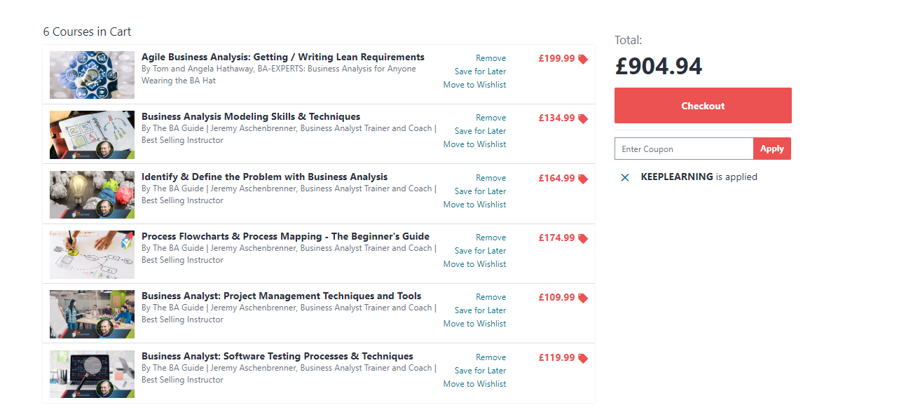

And then agile, bug types of bugs, documentations of QA process and with business analyst

Agile scrum mastery

Istqb agile testing certificate

Istqb test manager………. Take the exam

Then Finance….. the final goal

1. Financial analyst and investor course… finish it
2. Business data analyst with
3. Financial accounting

From this point we start googling rich successful companies and firms and people and start setting up for our biz we should have our web sorted with automation testcase , integrated and online with maven or gradles …and using Jenkins to do updates or test with performance and security test and know testing and business analysis testing then start getting loans or funds from ban or whatever make loads of friends go to seminars get chartered then . No more courses to buy except a new technology

Enreidem [steelblast007@gmail.com](mailto:steelblast007@gmail.com) First22*

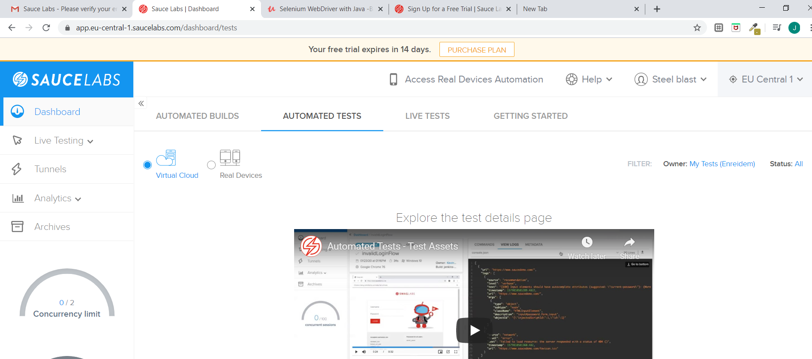

Use remote webdriver like u did when u ran in selenium grid

To get desired capability go to the saucelab diectorry and fill it in and it generates it

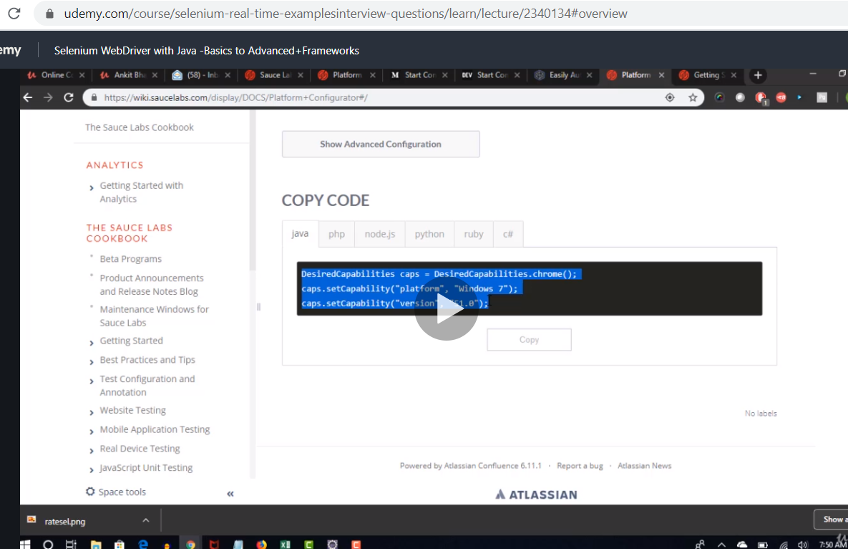

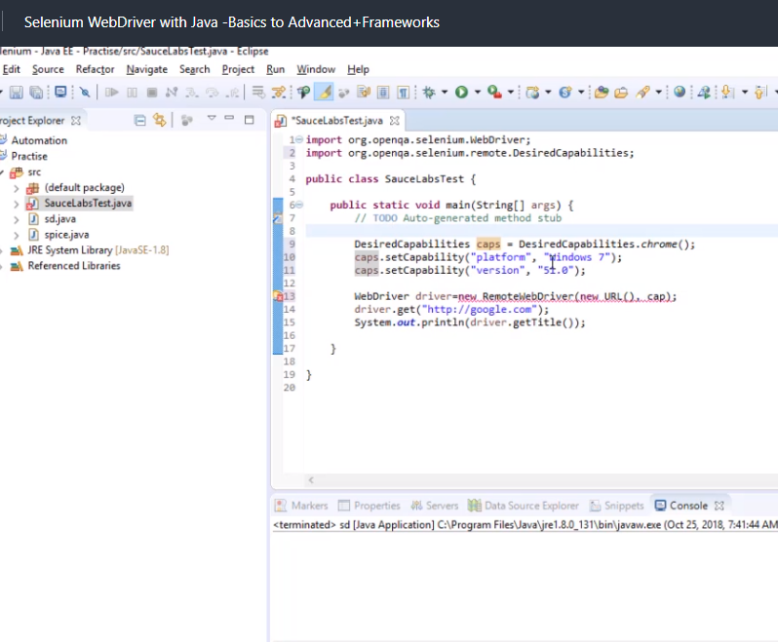

code download

import java.net.MalformedURLException;

import java.net.URL;

import org.openqa.selenium.WebDriver;

import org.openqa.selenium.remote.DesiredCapabilities;

import org.openqa.selenium.remote.RemoteWebDriver;

public class SauceLabsTest {

public static final String USERNAME = "rahul2";

  public static final String ACCESS_KEY = "xxxxx";

  public static final String URL = "http://" + USERNAME + ":" + ACCESS_KEY + "@ondemand.saucelabs.com:80/wd/hub";

public static void main(String[] args) throws MalformedURLException {

// TODO Auto-generated method stub

DesiredCapabilities caps = DesiredCapabilities.chrome();

caps.setCapability("platform", "Windows 7");

caps.setCapability("version", "51.0");

WebDriver driver=new RemoteWebDriver(new URL(URL), caps);

driver.get("http://google.com");

System.out.println(driver.getTitle());

}

}